**Sounds In Pictures**

Students or groups are given one picture each and they challenge each other to find words with certain phonemes in. If one team finds a sound which the other team can't, it's a point. This is good practice of both vocabulary and pronunciation.

***For example:***

*Group A*: OK, we have /r/ with **receptionist**.  
*Group B*: We don't have /r/. Oh, yes. We have /r/ with **roof**.

The game can be adapted for any level of vocabulary. Try to use pictures with a similar number of objects in them such as these two.

**Picture A**

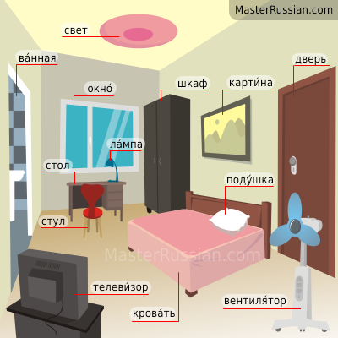



**Picture B**

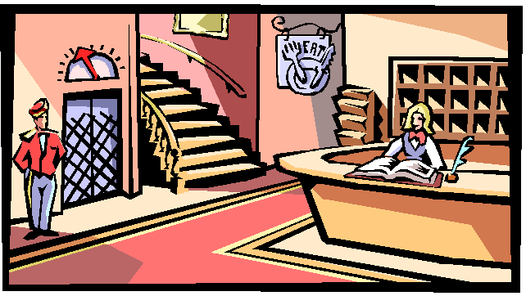

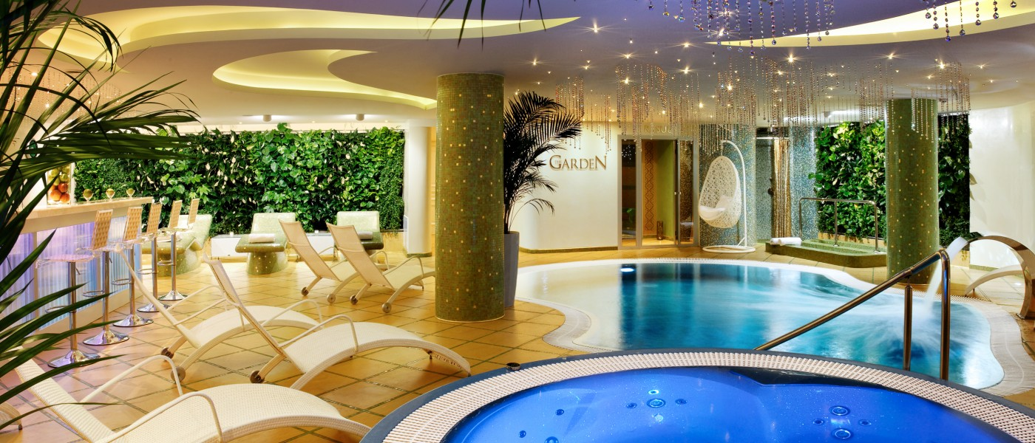





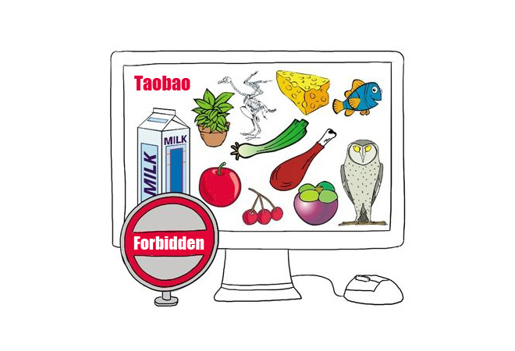



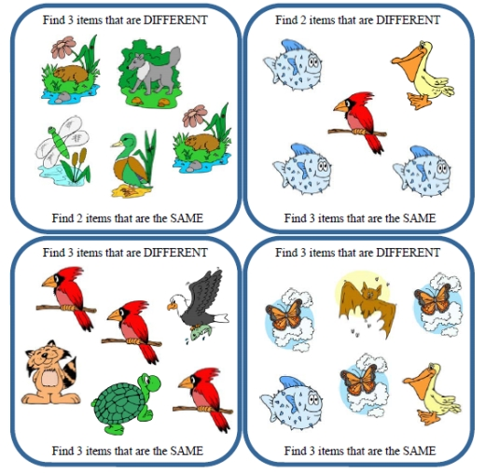





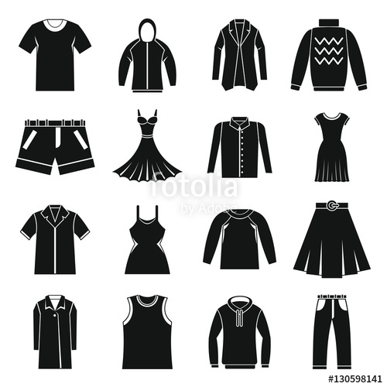

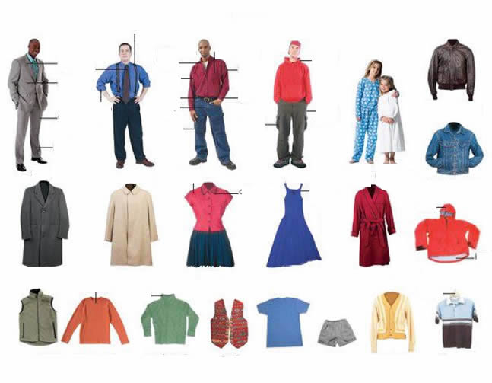



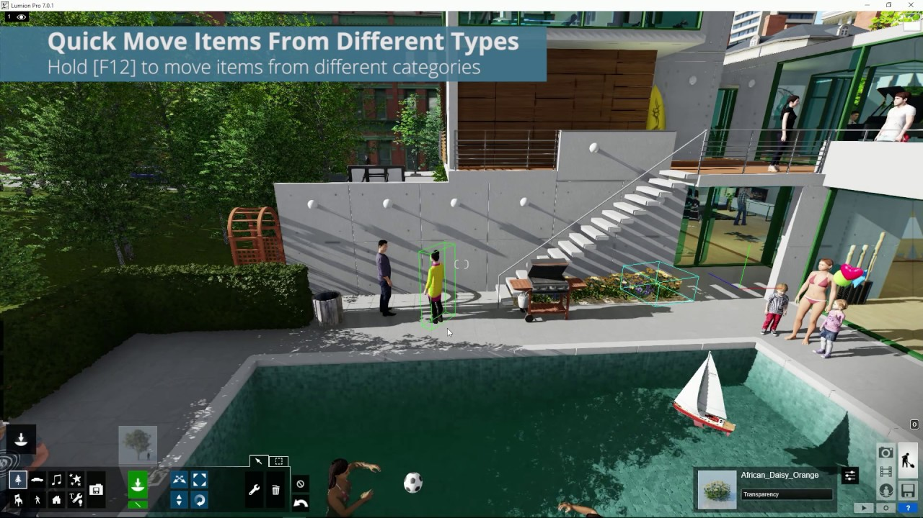



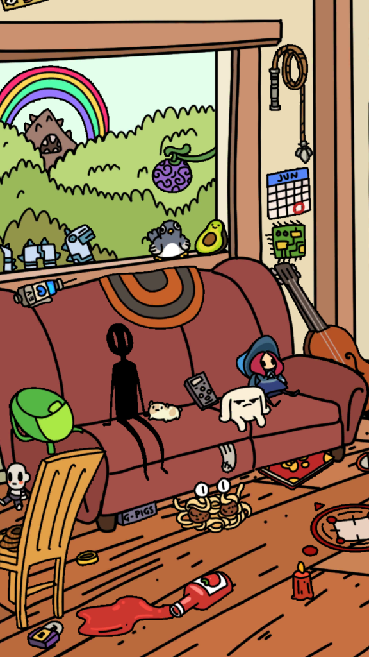



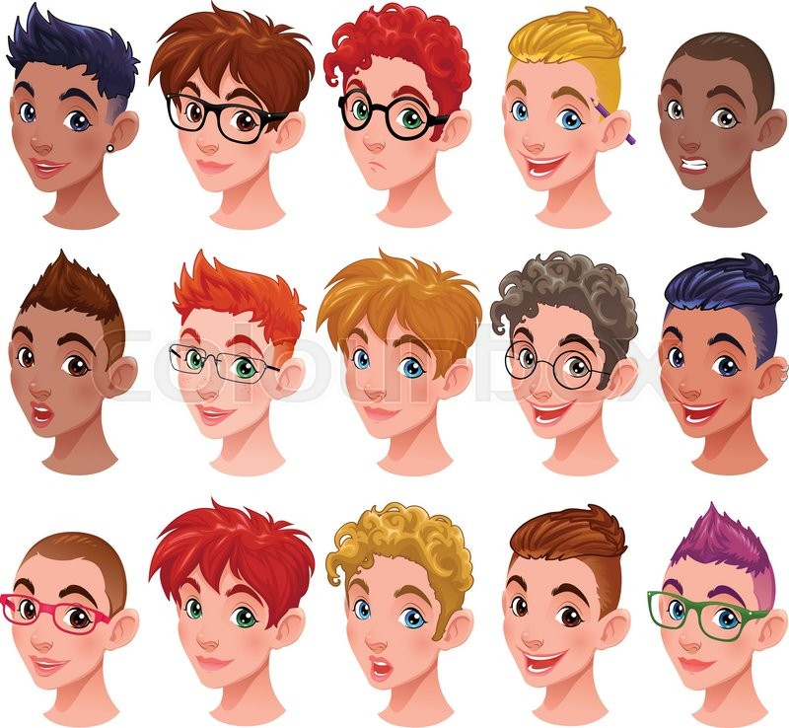

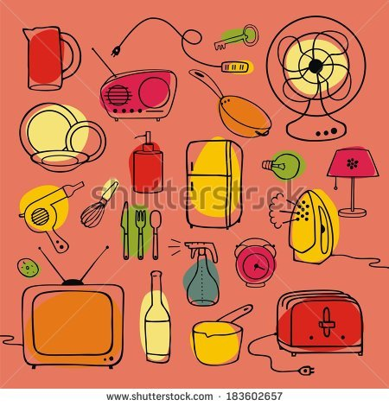



**Find The Homophones**

Which word has the same pronunciation as the question word?

**1. sew**a) sir  
d) saw  
c) so

**2. steel**a) still  
b) steal  
c) style

**3. fair**a) fur  
b) fear  
c) fare

**4. here**a) hair  
b) her  
c) hear

**5. too**a) two  
b) tar  
c) toe

**6. mail**a) mile  
b) male  
c) mill

**7. wait**a) wheat  
d) weight  
c) white

**8. bear**  
a) bare  
b) beer  
c) bar

9**. lay / lie**

   True

   False

10. **fool / foal**

   True

   False

11. **floor / flaw**

   True

   False

12. **arm / harm**

   True

   False

13. **hour / our**

   True

   False

14. **tour / tower**

   True

   False

15. **air / heir**

   True

   False

16. **pane / pain**

   True

   False

17. **sea / see**

   True

   False

18. **no / now**

   True

   False

19. **cell / sell**

   True

   False

20. **fought / thought**

   True

   False

21. **out / ought**

   True

   False

22. **flour / flower**

   True

   False

23. **peace / piece**

   True

   False

24. **cat / cart**

   True

   False

25. **where / wear**

   True

   False

26. **sow / saw**

   True

   False

27. **sum / some**

   True

   False

28. **there / they**

   True

   False

29. **pip / peep**

   True

   False

30. **wood / would**

   True

   False

31. **write / right**

   True

   False

32. **thought / fort**

   True

   False

**Silent Letters Worksheet** Which letter in these words is silent?

33. receipt

1. c
2. i
3. p
4. t

34. doubt

1. u
2. b
3. t

35. gnome

1. g
2. n
3. m

36. halves

1. h
2. l
3. v
4. s

37. whale

1. w
2. h
3. l

38. wrong

1. w
2. r
3. n
4. g39. ballet
5. b
6. l
7. t40. excerpt
8. x
9. c
10. p
11. t

**Silent Letters Worksheet 2**

Which letter in these words is silent?

41. dumb

   a. d

   b. m

   c. b

42. aisle

   a. s

   b. l

43. raspberry

   a. s

   b. p

   c. b

   d. r

44. champagne

   a. c

   b. m

   c. g

   d. n

45. climb

   a. l

   b. m

   c. b

46. autumn

   a. a

   b. m

   c. n

47. ghost

   a. g

   b. h

   c. s

   d. t

48. knife

   a. k

   b. n

   c. f

**Which one is different?**

**It may be a vowel or one of the consonants.**

1. a) mouse b) now c) taught d) howler

2. a) new b) sue c)do d) sew

3. a) think b)breath c)breathe d)thumb

4. a) name b)lamp c)pay d)stain

5. a) would b) wood c) could d)moon

6. a) see b) men c) mean d) seen

7. a) use b) useless c) useful d) be used to

8. a) come b) up c) won d) stool

9. a) stoke b) stop c) odd d) dot

10. a) computer b) stick c) nice d) bark

**Silent Letters Worksheet 3**

Which letter in these words is silent?

11. align

   a. l

   b. g

   c. n

12. Wednesday

   a. w

   b. d

   c. n

   d. s

13. castle

   a. s

   b. t

   c. l

14. thumb

   a. t

   b. m

   c. b

15. rendezvous

   a. n

   b. d

   c. z

   d. v

16. know

   a. k

   b. n

   c. o

17. guest

   a. u

   b. s

   c. t

18. sword

   a. w

   b. r

   c. d

**Word Stress Worksheet**

Look at each of these words. Decide on which syllable the stress falls?

*Example: a****bout****- 2nd syllable, bio****log****ical - 3rd syllable.*

19. receipt

   a. 1st

   b. 2nd

20. kitchen

   a. 1st

   b. 2nd

21. believable

   a. 1st

   b. 2nd

   c. 3rd

   d. 4th

22. deception

   a. 1st

   b. 2nd

   c. 3rd

23. thirteen

   a. 1st

   b. 2nd

24. thirty

   a. 1st

   b. 2nd

25. tomato

   a. 1st

   b. 2nd

   c. 3rd

26. bathroom

   a. 1st

   b. 2nd

**Word Stress Worksheet**

Look at each of these words. Decide on which syllable the stress falls?

*Example: a****bout****- 2nd syllable, bio****log****ical - 3rd syllable.*

27. reception

   a. 1st

   b. 2nd

   c. 3rd

28. comparison

   a. 1st

   b. 2nd

   c. 3rd

   d. 4th

29. potato

   a. 1st

   b. 2nd

   c. 3rd

30. bedroom

   a. 1st

   b. 2nd

31. fourteen

   a. 1st

   b. 2nd

32. forty

   a. 1st

   b. 2nd

33. delicious

   a. 1st

   b. 2nd

   c. 3rd

34. playful

   a. 1st

   b. 2nd

**Word Stress Worksheet**

Look at each of these words. Decide on which syllable the stress falls?

*Example: a****bout****- 2nd syllable, bio****log****ical - 3rd syllable.*

35. personal

   a. 1st

   b. 2nd

   c. 3rd

36. personnel

   a. 1st

   b. 2nd

   c. 3rd

37. adjective

   a. 1st

   b. 2nd

   c. 3rd

38. enhance

   a. 1st

   b. 2nd

39. Canadian

   a. 1st

   b. 2nd

   c. 3rd

   d. 4th

40. Japanese

   a. 1st

   b. 2nd

   c. 3rd

41. psychology

   a. 1st

   b. 2nd

   c. 3rd

   d. 4th

42. politician

   a. 1st

   b. 2nd

   c. 3rd

1. 4th

**Word Stress Worksheet**

Look at each of these words. Decide on which syllable the stress falls?

*Example: a****bout****- 2nd syllable, bio****log****ical - 3rd syllable.*

43. industrial

   a. 1st

   b. 2nd

   c. 3rd

   d. 4th

44. fantastic

   a. 1st

   b. 2nd

   c. 3rd

45. today

   a. 1st

   b. 2nd

46. frightened

   a. 1st

   b. 2nd

47. energy

   a. 1st

   b. 2nd

   c. 3rd

48. employment

   a. 1st

   b. 2nd

   c. 3rd

49. certificate

   a. 1st

   b. 2nd

   c. 3rd

   d. 4th

50. independent

   a. 1st

   b. 2nd

   c. 3rd

   d. 4th

**Consonant Phonemes: Odd One Out**

Look at the following groups of words and the underlined consonant phonemes.

Which one is different from the others?

1. a) church b) Chester c)such  d) ridge

2. a) shape b) hiss  c) push  d) passion

3. a) German b) justice c) chicken d) postage

4.  a) yacht b) university c) major d) you

5.  a) gate b) pig  c) germs d) great

6.  a) cat b) nice   c) ceiling d) sensitive

7.  a) think b) mother c) mammoth  d) thanks

8. a) vision b) buzz  c) zip d) lazy

**Word Stress Worksheet**

Look at each of these words. Decide on which syllable the stress falls?

*Example: a****bout****- 2nd syllable, bio****log****ical - 3rd syllable.*

9. photo

   a. 1st

   b. 2nd

10. photography

   a. 1st

   b. 2nd

   c. 3rd

   d. 4th

11. photographic

   a. 1st

   b. 2nd

   c. 3rd

   d. 4th

12. decide

   a. 1st

   b. 2nd

13. decision

   a. 1st

   b. 2nd

   c. 3rd

14. bakery

   a. 1st

   b. 2nd

   c. 3rd

15. understand

   a. 1st

   b. 2nd

   c. 3rd

16. attention

   a. 1st

   b. 2nd

   c. 3rd

How many syllables are there in each word? Choose the correct answer.

17. monkey  
a) 1  
b) 2  
c) 3  
d) 4

18. relocation  
a) 1  
b) 2  
c) 3  
d) 4

19. magnet  
a) 1  
b) 2  
c) 3  
d) 4

20. slobs  
a) 1  
b) 2  
c) 3  
d) 4

21. characterise  
a) 1  
b) 2  
c) 3  
d) 4

22. travelling  
a) 1  
b) 2  
c) 3  
d) 4

23. rocket  
a) 1  
b) 2  
c) 3  
d) 4

24. trying  
a) 1  
b) 2  
c) 3  
d) 4

25. garden  
a) 1  
b) 2  
c) 3  
d) 4

26. caterpillar  
a) 1  
b) 2  
c) 3  
d) 4

**How Many Syllables, Worksheet 2**

How many syllables are there in each word? Choose the correct answer.

27. beginning  
a) 1  
b) 2  
c) 3  
d) 4

28. architecture  
a) 1  
b) 2  
c) 3  
d) 4

29. capitalise  
a) 1  
b) 2  
c) 3  
d) 4

30. octopus  
a) 1  
b) 2  
c) 3  
d) 4

31. liveliness  
a) 1  
b) 2  
c) 3  
d) 4

32. delicacy  
a) 1  
b) 2  
c) 3  
d) 4

33. elation  
a) 1  
b) 2  
c) 3  
d) 4

34. popular  
a) 1  
b) 2  
c) 3  
d) 4

35. nobody  
a) 1  
b) 2  
c) 3  
d) 4

36. deeper  
a) 1  
b) 2  
c) 3  
d) 4

**How Many Syllables, Worksheet 3**

How many syllables are there in each word? Choose the correct answer.

37. heater  
a) 1  
b) 2  
c) 3  
d) 4

38. window  
a) 1  
b) 2  
c) 3  
d) 4

39. animal  
a) 1  
b) 2  
c) 3  
d) 4

40. photograph  
a) 1  
b) 2  
c) 3  
d) 4

41. time  
a) 1  
b) 2  
c) 3  
d) 4

42. slipper  
a) 1  
b) 2  
c) 3  
d) 4

43. passionate  
a) 1  
b) 2  
c) 3  
d) 4

44. appreciate  
a) 1  
b) 2  
c) 3  
d) 4

45. goes  
a) 1  
b) 2  
c) 3  
d) 4

46. timer  
a) 1  
b) 2  
c) 3  
d) 4

How many syllables are there in each word? Choose the correct answer.

47. acceptation  
a) 1  
b) 2  
c) 3  
d) 4

48. ladybug  
a) 1  
b) 2  
c) 3  
d) 4

49. computer  
a) 1  
b) 2  
c) 3  
d) 4

50. enjoying  
a) 1  
b) 2  
c) 3  
d) 4

**How Many Syllables, Worksheet 5**

How many syllables are there in each word? Choose the correct answer.

1. adventure  
a) 1  
b) 2  
c) 3  
d) 4

2. splits  
a) 1  
b) 2  
c) 3  
d) 4

3. zipper  
a) 1  
b) 2  
c) 3  
d) 4

4. necklace  
a) 1  
b) 2  
c) 3  
d) 4

5. adults  
a) 1  
b) 2  
c) 3  
d) 4

6. impulsive  
a) 1  
b) 2  
c) 3  
d) 4

7. years  
a) 1  
b) 2  
c) 3  
d) 4

8. excitement  
a) 1  
b) 2  
c) 3  
d) 4

9. flying  
a) 1  
b) 2  
c) 3  
d) 4

10. dividend  
a) 1  
b) 2  
c) 3  
d) 4

**How Many Syllables, Worksheet 6**

How many syllables are there in each word? Choose the correct answer.

11. suitable  
a) 1  
b) 2  
c) 3  
d) 4

12. departmental  
a) 1  
b) 2  
c) 3  
d) 4

13. from  
a) 1  
b) 2  
c) 3  
d) 4

14. drives  
a) 1  
b) 2  
c) 3  
d) 4

15. pumpkin  
a) 1  
b) 2  
c) 3  
d) 4

16. victory  
a) 1  
b) 2  
c) 3  
d) 4

17. crafts  
a) 1  
b) 2  
c) 3  
d) 4

18. dinosaur  
a) 1  
b) 2  
c) 3  
d) 4

19. fried  
a) 1  
b) 2  
c) 3  
d) 4

20. walks  
a) 1  
b) 2  
c) 3  
d) 4

**How Many Syllables, Worksheet 7**

How many syllables are there in each word? Choose the correct answer.

21. bumblebee  
a) 1  
b) 2  
c) 3  
d) 4

22. won't  
a) 1  
b) 2  
c) 3  
d) 4

23. merriment  
a) 1  
b) 2  
c) 3  
d) 4

24. denying  
a) 1  
b) 2  
c) 3  
d) 4

25. eyes  
a) 1  
b) 2  
c) 3  
d) 4

26. frying  
a) 1  
b) 2  
c) 3  
d) 4

27. hamburger  
a) 1  
b) 2  
c) 3  
d) 4

28. ponytail  
a) 1  
b) 2  
c) 3  
d) 4

29. arbitrary  
a) 1  
b) 2  
c) 3  
d) 4

30. classes  
a) 1  
b) 2  
c) 3  
d) 4

Task #2: Write each line in normal English orthography.

1: [ðә tajm hæz cʌm]

2: [ðә wɑlrәs sed]

3: [tu tɑlk әv mɛni θɪŋz]

4: [әv ʃuz ɑnd ʃɪps]

5: [ænd silɪŋ wæx]

6: [әv kæbәgәz ænd kɪŋz]

7: [ænd wɑj ðә si ɪs bojlɪŋ hɑt]

8: [ænd wɛθәr pɪgz hæv wɪŋz]

Phonetics Practice Exercises I (Answers)

Linguistics 201

I. Write each of the following words in phonetic transcription.

1. heat [hit] 6. shrink [ʃrɪŋk]

2. stroke [strowk] 7. toque [tuk]

3. phase [fejz] 8. attentive [ətɛ́ntɪv]

4. chump [tʃʌmp] 9. flop [flɑp]

5. loonie [luni] 10. wrath [ræθ]

II. The following is a phonetic transcription of an excerpt of the poem "The Walrus and

the Carpenter", from Lewis Carroll's book Through the Looking Glass. Each line of the

poem contains one word that is transcribed incorrectly, at the phonemic or "broad"

level of transcription.

Task #1: Identify the word that has been transcribed incorrectly, and then write the

correct form of the transcription.

Task #2: Write each line in normal English orthography.

1: [ðə tajm hæz cʌm] Correction: [cʌm] → [kʌm]

Orthography: the time has come

2: [ðə wɑlrəs sed] Correction: [sed] → [sɛd]

Orthography: the walrus said

3: [tu tɑlk əv mɛni θɪŋz] Correction: [tɑlk] → [tɑk]

Orthography: to talk of many things

4: [əv ʃuz ɑnd ʃɪps] Correction: [ɑnd] → [ænd]

Orthography: of shoes and ships

5: [ænd silɪŋ wæx] Correction: [wæx] → [wæks]

Orthography: and sealing wax

6: [əv kæbəgəz ænd kɪŋz] Correction: [kæbəgəz] → [kæbədʒəz]

Orthography: of cabbages and kings

7: [ænd wɑj ðə si ɪs bojlɪŋ hɑt] Correction: [ɪs] → [ɪz]

Orthography: and why the sea is boiling hot

8: [ænd wɛθər pɪgz hæv wɪŋz] Correction: [wɛθər] → [wɛðər]